**INTERNSHIP PROJECT REPORT**

(Term Jan-May, 2019)

**FREELANCER PROJECT**

Submitted By

**Name: Chandan Swain**

**Registration Number: 11506404**

**Course Code: CSE441**

Under the guidance of

**Ms. Shilpa Mahajani (Academy Campus Manager)**

**(Cognizant technology solutions)**

**School of Computer Science and Engineering**



**DECLARATION**

I hereby declare that the project work entitled (“Resource Requisition Automation Tool”) is an authentic record of our own work carried out as requirements of Internship for the award of B.Tech degree in Computer Science and Engineering from Lovely Professional University, Phagwara, under the guidance of **Mr. Abhinandan Chivate** during (19th January 2019 to 30th April 2019). All the information furnished in this project report is based on my own intensive work and is genuine.

Name of Student: Chandan Swain

Registration Number:11506404

Signature

Date:16-04-2019

CONTINUOUS ASSESSMENT (CA) for INTERNSHIP

(By external internship in-charge from organization)

Name of the Student: **____________** Registration Number **____________**

Internship Project Title (if any): **_________________**

Name of Organization & Address: **_____________________**

Name of External Internship in-charge (with mobile number): _________________________

|  |  |  |  |
| --- | --- | --- | --- |
| S.No | Criteria | Marks Obtained | Maximum Marks |
| 1 | Student conduct during internship |  | 10 |
| 2 | Punctuality and Enthusiasm |  | 20 |
| 3 | Technical Skill & Knowledge |  | 20 |
| 4 | Internship Project Marks |  | 50 |
|  | TOTAL |  | 100 |

Date **___________** Authorized Signatory __________________

Name of External Internship in-charge: ________________

Designation:

Company Seal

Note: The external internship in-charge will mark the continuous assessment at the end of semester / internship. Students must ensure that evaluation marks are provided by the organization as per above parameters in the given format during ETP.

**CERTIFICATE**

This is to certify that the declaration statement made by student is correct to the best of my knowledge and belief. He has completed this Internship under my guidance and supervision. The present work is the result of his original investigation, effort and study. No part of the work has ever been submitted for any other degree at any University. The Internship Project is fit for the submission and partial fulfillment of the conditions for the award of B.Tech degree in Computer Science and Engineering from Lovely Professional University, Phagwara.

**Signature and Name of the Mentor[Cognizant]**

**Name:Shilpa Mahajani**

**Signature:**

**Designation:**

**School of Computer Science and Engineering,**

Lovely Professional University,

Phagwara, Punjab

Date:16-04-2019

**ACKNOWLEDGEMENT**

The internship opportunity I had with **Cognizant Technology Solutions** was a great chance for learning and professional development. Therefore, I consider myself as a very lucky individual as I was provided with an opportunity to be a part of it. I am also grateful for having a chance to meet so many wonderful people and professionals who led me though this internship period.

Bearing in mind previous I am using this opportunity to express my deepest gratitude and special thanks to the **Ms. Shilpa Mahajani**, [Designation] who in spite of being extraordinarily busy with her duties, took time out to hear, guide and keep me on the correct path and allowing me to carry out my project at their esteemed organization and extending during the training.

I express my deepest thanks to **Abhinandan Chivate** for taking part in useful decision & giving necessary advices and guidance and arranged all facilities to make life easier. I choose this moment to acknowledge her contribution gratefully.

Chandan Swain

11506404

**TABLE OF CONTENTS**

1.INTRODUCTION 8

1.1 DESCRIPTION 8

1.2TECHNOLOGIES DESCRIPTION 9

1.2.1 JAVA 9

1.2.2 SPRING: - 10

1.2.3 HIBERNATE 11

1.2.3.1 Hibernate Advantages 12

1.2.4. JSP: - 12

1.2.4.1ADVANTAGES OF JSP 13

1.2.5 Eclipse: - 14

1.2.6 RDBMS 14

1.2.6.1 RDBMS TERMINOLOGY: - 14

1.2.7 MYSQL DATABASE: - 15

2.PROFILE OF PROBLEM 16

2.1 SELF-DISCIPLINE 16

2.2 SELF-MOTIVATION 16

2.3 Future Planning 17

2.4 Dealing with clients 17

2.5 Money Matters 18

3.Existing System 18

3.1 Introduction 18

3.2 DFD for Present System 18

3.2.1 Context Level DFD (Level 0) 19

3.2.1.1 ADMIN 19

3.2.1.2 USER 19

3.2.2 First Level DFD 20

3.2.2.1 USER 20

3.2.2.2 Admin 20

4. PROBLEM ANALYSIS 21

4.1 PRODUCT DEFINITION 21

4.2 FEASIBILITY ANALYSIS 21

4.2.1 TECHNICAL FEASIBILITY 22

5. Software Requirement Analysis 23

5.1 Introduction 23

5.1.1 PURPOSE 23

5.1.2 SCOPE 23

5.2 GENERAL DESCRIPTION 23

5.2.1 PRODUCT DESCRIPTION. 24

5.2.2 USERS CHARACTERISTICS 24

5.3 Functional Requirements. 25

5.4 Software and hardware Requirement 30

5.5 Technologies Recommended 30

6. DESIGN 31

6.1 Use Case Diagram 31

6.2 Context Level DFD: - 32

6.3 Flow Chart Diagram 33

7. TESTING 34

7.1 Testing Strategies 34

7.1.1 Unit Testing 34

7.1.2 Integration Testing 34

7.1.2.1 Top Down Integration testing 35

7.1.2.2 Bottom-up Integration testing 35

7.1.3 System Testing 35

7.1.4 Acceptance Testing 35

7.1.4.1 Alpha Testing 35

7.2 Testing Methods 36

7.2.1 White Box Testing 36

7.2.2 Black Box Testing 36

7.3 Validation 36

7.4 Limitations 36

7.5 Test Results 36

TEST CASES 1 37

Test Case 3 39

8. IMPLEMENTATION 40

8.1 PROCESS 40

8.2 PROCESS MODEL USED BY US 40

8.2.1 Agile Methodology 40

8.2.1.1 Scrum 41

8.3 CONVERSION PLAN 42

9 PROJECT LEGACY 43

9.1 Current State of the project 43

9.2 Technical and Managerial lessons learnt 43

9.2.1 Technical lessons learnt 43

9.2.2 Managerial lessons learnt 43

10.USER INTERFACE SCREENSHOTS 44

11.Bibliography 48

# 1.INTRODUCTION

## 1.1 DESCRIPTION

A freelancer of freelance worker is a term commonly used for a person who is self-employed and is not necessarily committed to a particular employer long-term. While the term “independent contractor” is sometimes used to designate the tax and employment classes of this type of worker, the term freelancing is most common in culture and creative industries. Freelance workers are sometimes represented by a company or a temporary agency hat resells freelancer labor to clients; other work independently or use professional associations or websites to get work.

Fields where freelancers work are predominantly in music, acting, writing, acting, computer programming, web design, translating, illustrating, film, video production, and other forms of work which some cultural theorists consider as central to the cognitive-cultural economy. A freelancer can also be a self-employed person offering services, usually to businesses and often to multiple clients at a time. The type of work freelancers does vary. Nearly every type pf service a business would need could be provided by a freelancer, including but not limited to marketing such as social media marketing, copywriting, publicity, writing, technological support, such as programming, interior design, graphic design, and book keeping.

## 1.2TECHNOLOGIES DESCRIPTION

Technologies and tools that are used to build this project are: -

### 1.2.1 JAVA

Java is a high-level programming language originally developed by Sun Microsystems and released in 1995. Java runs on a variety of platforms, such as Windows, Mac OS, and the various versions of UNIX. Java is guaranteed to be **Write Once, Run Anywhere.**

Java is −

* **Object Oriented** − In Java, everything is an Object. Java can be easily extended since it is based on the Object model.
* **Platform Independent** − Unlike many other programming languages including C and C++, when Java is compiled, it is not compiled into platform specific machine, rather into platform independent byte code. This byte code is distributed over the web and interpreted by the Virtual Machine (JVM) on whichever platform it is being run on.
* **Simple** − Java is designed to be easy to learn. If you understand the basic concept of OOP Java, it would be easy to master.
* **Secure** − With Java's secure feature it enables to develop virus-free, tamper-free systems. Authentication techniques are based on public-key encryption.
* **Architecture-neutral** − Java compiler generates an architecture-neutral object file format, which makes the compiled code executable on many processors, with the presence of Java runtime system.
* **Portable** − Being architecture-neutral and having no implementation dependent aspects of the specification makes Java portable. Compiler in Java is written in ANSI C with a clean portability boundary, which is a POSIX subset.
* **Robust** − Java makes an effort to eliminate error prone situations by emphasizing mainly on compile time error checking and runtime checking.
* **Multithreaded** − With Java's multithreaded feature it is possible to write programs that can perform many tasks simultaneously. This design feature allows the developers to construct interactive applications that can run smoothly.
* **Interpreted** − Java byte code is translated on the fly to native machine instructions and is not stored anywhere. The development process is more rapid and analytical since the linking is an incremental and light-weight process.
* **High Performance** − With the use of Just-In-Time compilers, Java enables high performance.
* **Distributed** − Java is designed for the distributed environment of the internet.
* **Dynamic** − Java is considered to be more dynamic than C or C++ since it is designed to adapt to an evolving environment. Java programs can carry extensive amount of run-time information that can be used to verify and resolve accesses to objects on run-time.

### 1.2.2 SPRING: -

Spring is a lightweight framework. It can be thought of as a framework of frameworks because it provides support to various frameworks such as Struts, Hibernate, Tapestry, EJB, JSF etc. The framework, in broader sense, can be defined as a structure where we find solution of the various technical problems.The Spring framework comprises several modules such as IOC, AOP, DAO, Context, ORM, WEB MVC etc. We will learn these modules in next page. Let's understand the IOC and Dependency Injection first.

The core features of the Spring Framework can be used in developing any Java application, but there are extensions for building web applications on top of the Java EE platform. Spring framework targets to make J2EE development easier to use and promotes good programming practices by enabling a POJO-based programming model.

Following is the list of few of the great benefits of using Spring Framework −

* Spring enables developers to develop enterprise-class applications using POJOs. The benefit of using only POJOs is that you do not need an EJB container product such as an application server but you have the option of using only a robust servlet container such as Tomcat or some commercial product.
* Spring is organized in a modular fashion. Even though the number of packages and classes are substantial, you have to worry only about the ones you need and ignore the rest.
* Spring does not reinvent the wheel, instead it truly makes use of some of the existing technologies like several ORM frameworks, logging frameworks, JEE, Quartz and JDK timers, and other view technologies.
* Testing an application written with Spring is simple because environment-dependent code is moved into this framework. Furthermore, by using JavaBean style POJOs, it becomes easier to use dependency injection for injecting test data.
* Spring's web framework is a well-designed web MVC framework, which provides a great alternative to web frameworks such as Struts or other over-engineered or less popular web frameworks.
* Spring provides a convenient API to translate technology-specific exceptions (thrown by JDBC, Hibernate, or JDO, for example) into consistent, unchecked exceptions.
* Lightweight IoC containers tend to be lightweight, especially when compared to EJB containers, for example. This is beneficial for developing and deploying applications on computers with limited memory and CPU resources.
* Spring provides a consistent transaction management interface that can scale down to a local transaction (using a single database, for example) and scale up to global transactions (using JTA, for example).

### 1.2.3 HIBERNATE

Hibernate is an **O**bject-**R**elational **M**apping (ORM) solution for JAVA. It is an open source persistent framework created by Gavin King in 2001. It is a powerful, high performance Object-Relational Persistence and Query service for any Java Application.

Hibernate maps Java classes to database tables and from Java data types to SQL data types and relieves the developer from 95% of common data persistence related programming tasks.

Hibernate sits between traditional Java objects and database server to handle all the works in persisting those objects based on the appropriate O/R mechanisms and patterns.

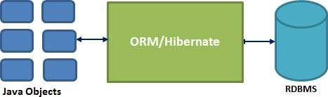

#### 1.2.3.1 Hibernate Advantages

* Hibernate takes care of mapping Java classes to database tables using XML files and without writing any line of code.
* Provides simple APIs for storing and retrieving Java objects directly to and from the database.
* If there is change in the database or in any table, then you need to change the XML file properties only.
* Abstracts away the unfamiliar SQL types and provides a way to work around familiar Java Objects.
* Hibernate does not require an application server to operate.
* Manipulates Complex associations of objects of your database.
* Minimizes database access with smart fetching strategies.

### 1.2.4. JSP: -

Java Server Pages (JSP) is a server-side programming technology that enables the creation of dynamic, platform-independent method for building Web-based applications. JSP have access to the entire family of Java APIs, including the JDBC API to access enterprise databases.

Java Server Pages (JSP) is a technology for developing Webpages that supports dynamic content. This helps developers insert java code in HTML pages by making use of special JSP tags, most of which start with <% and end with %>.

A Java Server Pages component is a type of Java servlet that is designed to fulfill the role of a user interface for a Java web application. Web developers write JSPs as text files that combine HTML or XHTML code, XML elements, and embedded JSP actions and commands.

Using JSP, you can collect input from users through Webpage forms, present records from a database or another source, and create Webpages dynamically.

JSP tags can be used for a variety of purposes, such as retrieving information from a database or registering user preferences, accessing JavaBeans components, passing control between pages, and sharing information between requests, pages etc.

#### 1.2.4.1ADVANTAGES OF JSP

Following table lists out the other advantages of using JSP over other technologies −

vs. Active Server Pages (ASP)

### The advantages of JSP are twofold. First, the dynamic part is written in Java, not Visual Basic or other MS specific language, so it is more powerful and easier to use. Second, it is portable to other operating systems and non-Microsoft Web servers.

vs. Pure Servlets

It is more convenient to write (and to modify!) regular HTML than to have plenty of println statements that generate the HTML.

vs. Server-Side Includes (SSI)

SSI is really only intended for simple inclusions, not for "real" programs that use form data, make database connections, and the like.

vs. JavaScript

JavaScript can generate HTML dynamically on the client but can hardly interact with the web server to perform complex tasks like database access and image processing etc.

vs. Static HTML

Regular HTML, of course, cannot contain dynamic information.

### 1.2.5 Eclipse: -

Eclipse is an [integrated development environment](https://en.wikipedia.org/wiki/Integrated_development_environment) (IDE) used in [computer programming](https://en.wikipedia.org/wiki/Computer_programming), and is the most widely used Java IDE. It contains a base [workspace](https://en.wikipedia.org/wiki/Workspace) and an extensible [plug-in](https://en.wikipedia.org/wiki/Plug-in_(computing)) system for customizing the environment. Eclipse is written mostly in [Java](https://en.wikipedia.org/wiki/Java_(programming_language)) and its primary use is for developing Java applications

### 1.2.6 RDBMS

A database is a separate application that stores a collection of data. Each database has one or more distinct APIs for creating, accessing, managing, searching and replicating the data it holds.

Other kinds of data stores can be used, such as files on the file system or large hash tables in memory but data fetching and writing would not be so fast and easy with those types of systems.

So nowadays, we use relational database management systems (RDBMS) to store and manage huge volume of data. This is called relational database because all the data is stored into different tables and relations are established using primary keys or other keys known as foreign keys.

Relational Database Management System (RDBMS) is a software that:

* Enables you to implement a database with tables, columns and indexes.
* Guarantees the Referential Integrity between rows of various tables.
* Updates the indexes automatically.
* Interprets an SQL query and combines information from various tables.

#### 1.2.6.1 RDBMS TERMINOLOGY: -

Before I proceed to explain MySQL database system, let's revise few definitions related to database.

* **Database:** A database is a collection of tables, with related data.
* **Table:** A table is a matrix with data. A table in a database looks like a simple spreadsheet.
* **Column:** One column (data element) contains data of one and the same kind, for example the column postcode.
* **Row:** A row (= tuple, entry or record) is a group of related data, for example the data of one subscription.
* **Redundancy:** Storing data twice, redundantly to make the system faster.
* **Primary Key:** A primary key is unique. A key value cannot occur twice in one table. With a key, you can find at most one row.
* **Foreign Key:** A foreign key is the linking pin between two tables.
* **Compound Key:** A compound key (composite key) is a key that consists of multiple columns, because one column is not sufficiently unique.
* **Index:** An index in a database resembles an index at the back of a book.
* **Referential Integrity:** Referential Integrity makes sure that a foreign key value always points to an existing row.

### 1.2.7 MYSQL DATABASE: -

MySQL is a fast, easy-to-use RDBMS being used for many small and big businesses. MySQL is developed, marketed, and supported by MySQL AB, which is a Swedish company. MySQL is becoming so popular because of many good reasons:

* MySQL is released under an open-source license. So you have nothing to pay to use it.
* MySQL is a very powerful program in its own right. It handles a large subset of the functionality of the most expensive and powerful database packages.
* MySQL uses a standard form of the well-known SQL data language.
* MySQL works on many operating systems and with many languages including PHP, PERL, C, C++, JAVA, etc.
* MySQL works very quickly and works well even with large data sets.
* MySQL is very friendly to PHP, the most appreciated language for web development.
* MySQL supports large databases, up to 50 million rows or more in a table. The default file size limit for a table is 4GB, but you can increase this (if your operating system can handle it) to a theoretical limit of 8 million terabytes (TB).
* MySQL is customizable. The open-source GPL license allows programmers to modify the MySQL software to fit their own specific environments.

# 2.PROFILE OF PROBLEM

## 2.1 SELF-DISCIPLINE

Freelancing gives you freedom, and you become your boss. This sounds fascinating, but at the same time; you need to be self-disciplined. You have to be **very sincere about your work**. Especially if you are an online freelancer, you are bound to get distracted easily. You need to understand “Time is money “, and you need to keep your focus on your work.

The most important factor of freelancing is to finish the projects within deadlines thus if you are planning to start freelancing make sure you have good [time management skills](https://www.shoutmeloud.com/time-management-tips-young-entrepreneurs.html). Initially, it may sound like not a big deal kind of thing, but as soon as you move ahead in your career, you will face the biggest problem of getting stuck in multiple things. If you stay organized from day one, you are bound to get success.

## 2.2 SELF-MOTIVATION

When you are working with a company, there are many programs and factors to help in motivation. But, when you work alone from home there are lots of factors which demotivates you or at least you can feel the lack of constant motivation. Problems with friends/family, lack of productivity, not enough earning, the bad day with the client and lots more, these factors can easily drag you away from creativity and your work. Thus, if you are like me who needs a mentor to keep me motivated and help you to get best out of you then to freelance would be the tough job for you.

A good idea is to keep your freelancing desk surrounded with stuff that keeps you motivated. It could be anything related to your earlier work, photos, motivational posters, or motivational music in background. Once in a while, you should consider watching motivational movies, to keep pushing you for more.

## 2.3 Future Planning

No matter what field you choose, planning is the first step towards success. To get success in freelancing, you need to be an efficient planner to plan about all projects, their deadlines, which project to accept and which to reject. You need to be sure what’s next is in your “To-Do Lists”, instead of hopping from one project to another and finishing none.

You need to use the proper software’s to keep track of your work, income, to-do lists, client details, etc. so that you can make the right plans and stick to it. You don’t need a lot of tools and software’s, but you need to pick few, which works best for you.

## 2.4 Dealing with clients

Apart from dealing with motivation, discipline, and planning, you also need to deal with your clients to get success in freelancing. The first job is to search for clients for the services you provide and for that you need to be innovative in your marketing skills.

Once you get a lead, you need to interact with him for pricing, job requirement and other information related to the project. Not every client is the same, and every time you will be dealing with different kind of clients. Few of them will be perfect to deal with, and few of them will be the biggest critics of your work and would hardly get satisfied with your work. Thus, if you can’t take criticism, then it’s going to be a tough way to be a successful freelancer. You have to keep your ego aside and learn to deal with different type of people when working online.

## 2.5 Money Matters

Maybe freelancing is your dream work, but you can’t ignore earning. Earning is always secondary when have passion in what you do but it do count. Thus, before leaving your full-time job make sure you have sufficient savings because it might take the time to start a good earning as a freelancer. Lack of money might discourage you.

Once you are fine to start with freelancing, you need to be confident about your work and charge for your services according. Analyze the market, clients and then decide how much you are going to charge. And do remember “**never put all eggs in one basket**.”

# 3.Existing System

## 3.1 Introduction

The liaison between employer & freelancer is typically fulfilled by a staffing organization. Success of a staffing company is dependent on bridging the right employer need towards an employee skill. Matching of the skill vs requirement cannot be efficiently performed using papers of physical forms. Digitization of physical forms followed by matching of skills & requirements helps to run the business efficiently.

The solution developed will address the objective in a holistic manner and will have all the features and functionalities which shall let the freelancer to register on the portal and submit proposals online. Similarly, the portal also allows admin to register and post the project requirement. The admin of the system be able to check on the Proposal, accept / reject it and the freelancer allowed to check on the status.

## 3.2 DFD for Present System



## 3.2.1 Context Level DFD (Level 0)

### 3.2.1.1 ADMIN

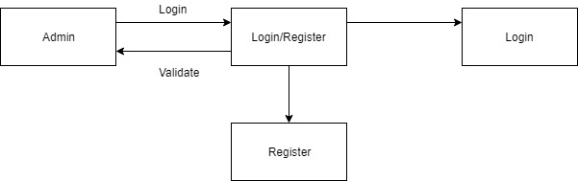

### 3.2.1.2 USER

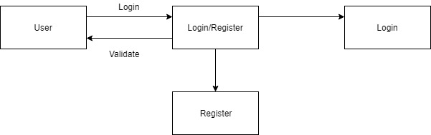

## 3.2.2 First Level DFD

### 3.2.2.1 USER

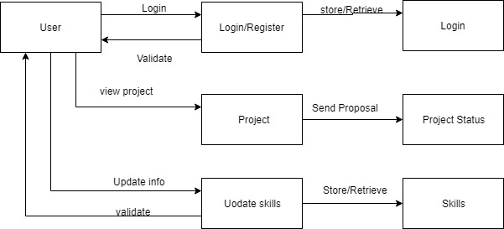

### C:\Users\765397\AppData\Local\Microsoft\Windows\INetCache\Content.Word\1st level dfd admin.jpg3.2.2.2 Admin

# 4. PROBLEM ANALYSIS

## 4.1 PRODUCT DEFINITION

**Product Name**: Freelancer Hire Website

**Product Objective:** Aims at providing facilities to Admin to add project and user to work on different projects available to them.

**Language Used:**

**Front End**: JAVA

**Back End**: MySQL

## 4.2 FEASIBILITY ANALYSIS

The feasibility for the project is done on the basis of the parameters like time required,

workers needed, hardware and software requirements, cost involved in the building of

this application. We check whether developing the project is beneficial.

Resources that are required to build up this project and make the testing system live

on the internet are:

Time – There are about 1-1.5 months to build up this project, starting from mid- March

2019 to end of April 2019.

Workers – The team must consist of the members skilled in coding of Java and must

be familiar with the concepts of Software Development.

This project was found to be completely feasible after the analysis done on the basis

of the above mention parameters.

### 4.2.1 TECHNICAL FEASIBILITY

The application is to be developed using JAVA Spring MVC Framework and MySQL. The pros and cons of the language were considered carefully so, to decide whether it is technically feasible to develop the website in JAVA or not.

* Spring Framework is lightweight.
* It works well with databases, excel sheet, Files, etc.
* Spring provides their own container for managing the bean lifecycle.
* This is another top feature of Spring framework where application dependencies are satisfied by the framework itself. Framework creates the object in runtime and satisfies application dependencies.
* Spring enables the developers to develop enterprise applications using POJOs (Plain Old Java Object). The benefit of developing the applications using POJO is, that we do not need to have an enterprise container such as an application server but we have the option of using a robust servlet container.

MySQL has been chosen over the other possibilities with the following reasoning:

* MySQL is license free for registered charities.
* MySQL can handle 50,000,000 + records.
* MySQL is an ideal database type to create a prototype of an e-commerce web site.
* The MySQL database can be easily upgraded to MS SQL at later date.

# 5. Software Requirement Analysis

## 5.1 Introduction

The introduction of the Software Requirements Specification (SRS) provides an overview of the entire SRS with purpose, scope, definitions, acronyms, abbreviations, references and overview of the SRS.

### 5.1.1 PURPOSE

The purpose of this SRS document is to provide a detailed overview of our software product, its parameters and goals. This document describes the project's target audience and its user interface, hardware and software requirements. It defines how our client, team and audience see the product and its functionality. Nonetheless, it helps any designer and developer to assist in software delivery lifecycle (SDLC) processes.

### 5.1.2 SCOPE

This SRS is aimed at specifying requirements of software to be developed but it can also be applied to get opinions of people and their views about it. The standard can be used to create software requirements specifications directly or can be used as a model for defining an organization or project specific standard. It does not identify any specific method, nomenclature or tool for preparing an SRS.

## 5.2 GENERAL DESCRIPTION

The remaining sections of this document provide a general description, including characteristics of the users of this project, the product's hardware, and the functional and data requirements of the product. General description of the project is discussed in section 2 of this document. Section 3 gives the functional requirements, data requirements and constraints and assumptions made. It also gives the user viewpoint of product. Section 3 also gives the specific requirements of the product. Section 3 also discusses the external interface requirements and gives detailed description of functional requirements. Section 4 is for supporting information.

### 5.2.1 PRODUCT DESCRIPTION.

This document contains the problem statement that the current system is facing which is not happening. It further contains the method and tools to efficiently stored the data and utilizes it in a convenient way. It also illustrates the way the data can be utilized to give people the opinions about a particular topic. It further lists and briefly describes the major features and a brief description of each of the proposed system.

The following SRS contains the detail product perspective from different users. It provides the detail product functions of sentimental analysis with user characteristics permitted constraints, assumptions and dependencies and requirements subsets.

### 5.2.2 USERS CHARACTERISTICS

**Admin: -**

1.Admin can register himself and add projects.

2.Admin can update or modify present requirements or skills.

3.Admin can accept the proposal or reject it.

**Lancer: -**

1.Lancer can register himself.

2.Lancer can view projects available to them based on the skills.

3.Lancer can update or modify its skills.

## 5.3 Functional Requirements.

The functional requirements are charted for each of the high level requirements called out in the earlier section:

Additionally, the following elements are captured for each business requirement in the table provided below: -

* Req. Type = (F Core Functionality, E Exception, UI User Interface, R Reporting)

** Priority of Requirement = (1=Base Functionality, 2=Advanced Functionality,

3=Additional Opportunities)

** Originator = (Name of the business process of the system/ department or function

|  |  |  |
| --- | --- | --- |
| **Value** | **Rating** | **Description** |
| **1** | Critical | This requirement is critical to the success of the project. The project will not be possible without this requirement. |
| **2** | High | This requirement is high priority, but the project can be implemented at a bare minimum without this requirement. |
| **3** | Medium | This requirement is somewhat important, as it provides some value but the project can proceed without it. |
| **4** | Low | This is a low priority requirement, or a “nice to have” feature, if time and cost allow it. |
| **5** | Future | This requirement is out of scope for this project, and has been included here for a possible future release. |

|  |  |  |  |  |  |  |
| --- | --- | --- | --- | --- | --- | --- |
| **Req. #** | **Rationale Categorization** | **Business Requirement** | **Req.**  **Type**  **\*** | **Priority**  **\*\*** | **Originator**  **\*\*\*** | **BR Traced to Business Requirement / Use case ID** |
| Req_1.1 | Admin Registration | When the admin clicks on Admin Registration link, it should re-direct to registration form | F | Critical | NA | Req_1 |
| Req_1.2 | Admin Registration | Admin needs to fill some of the basic attributes/fields as mentioned below in the requirement: First Name, Last Name, Contact Number, Email, Password | UI | Critical | NA | Req_1 |
| Req_1.3 | Admin Registration | Clicking ‘Submit’ should validate the datatype constraints for each field | F | Critical | NA | Req_1 |
| Req_1.4 | Admin Registration | Admin failing to provide information on the mandatory fields be provided with an alert message – ‘Please update the highlighted mandatory field(s).’ Also, highlight the missed out field in red | E | Medium | NA | Req_1 |
| Req_1.5 | Admin Registration | Post-successful field level validation, save the information in the database | F | Critical | NA | Req_1 |
| Req_1.6 | Admin Registration | Upon saving the information in the database, display the message ‘Your details are submitted successfully’. | UI | Medium | NA | Req_1 |
| Req_2.1 | Admin Credential Authentication | A registered admin – is able click ‘Admin Login’ link, after keying in ‘Email’ & ‘Password’ field and get his credentials authenticated with the existing database entry. | F | Critical | NA | Req_2 |

|  |  |  |  |  |  |  |
| --- | --- | --- | --- | --- | --- | --- |
| **Req. #** | **Rationale Categorization** | **Business Requirement** | **Req. Type \*** | **Priority \*\*** | **Originator \*\*\*** | **BR Traced to Business Requirement / Use case ID** |
| Req_3.1 | User Registration | When the User clicks on User Registration link, it should re-direct to User registration form | F | Critical | NA | Req_3 |
| Req_3.2 | User Registration | User needs to fill some of the basic attributes/fields as mentioned below in the requirement: First Name, Last Name, Contact Number, Email, Password | UI | Critical | NA | Req_3 |
| Req_3.3 | User Registration | User needs to select his Skills from available checkboxes | UI | Critical | NA | Req_3 |
| Req_3.4 | User Registration | Clicking ‘Submit’ should validate the datatype constraints for each field | F | Critical | NA | Req_3 |
| Req_3.5 | User Registration | Users failing to provide information on the mandatory fields be provided with an alert message – ‘Please update the highlighted mandatory field(s).’ Also, highlight the missed out field in red | E | Medium | NA | Req_3 |
| Req_3.6 | User Registration | Post-successful field level validation, save the information in the database | F | Critical | NA | Req_3 |
| Req_3.7 | User Registration | Upon saving the information in the database, display the message ‘Your details are submitted successfully’. | E | Medium | NA | Req_3 |
| Req_4.1 | User Credential Authentication | A registered user – is able click ‘User Login’ link, after keying in ‘Email’ & ‘Password’ field and get his credentials authenticated with the existing database entry. | F | Critical | NA | Req_4 |

|  |  |  |  |  |  |  |
| --- | --- | --- | --- | --- | --- | --- |
| Req_5.1 | Project Details | After successful login, admin should be able to view list of all projects they have made, and status of projects. | UI | Critical | NA | Req_5 |
| Req_5.2 | Project Details | On clicking name of any project, admin should be able to view status of project and list of proposals on that project | UI | Critical | NA | Req_5 |
| Req_5.3 | Project Details | A logged in admin, after clicking the new project link, should be redirected to a form that procures project details mentioned below – ‘Project Name’, ‘Duration’, ‘Budget’, ‘Skills’ | UI | Critical | NA | Req_5 |
| Req_5.4 | Project Details | Admin should be able to select skills from checkboxes | UI | Critical | NA | Req_5 |
| Req_5.5 | Project Details | Clicking ‘Submit’ should validate the datatype constraints for each field. | F | Critical | NA | Req_5 |
| Req_5.6 | Project Details | Admins failing to provide information on the mandatory fields be provided with an alert message – ‘Please update the highlighted mandatory field(s).’ Also, highlight the missed out field in red | E | Medium | NA | Req_5 |
| Req_5.7 | Project Details | Post-successful field level validation, save the information in the database | F | Critical | NA | Req_5 |
| Req_5.8 | Project Details | Upon saving the information in the database, display the message ‘Your details are submitted successfully | E | Medium | NA | Req_5 |
| Req_6.1 | Proposal Submit | After successful login, user should be able to view list of projects available based on Skills. Option to view complete list should also be there. | UI | Critical | NA | Req_6 |
| Req_6.2 | Proposal Submit | A logged in user, after viewing list of projects, on clicking a Project Name should be able to view all project details mentioned below – ‘Project Name’, ‘Duration’, ’Budget’, ’Skills’ | UI | Critical | NA | Req_6 |

|  |  |  |  |  |  |  |
| --- | --- | --- | --- | --- | --- | --- |
| Req_6.3 | Proposal Submit | If the skills of the project match the skills of current logged in user, Submit Proposal button should be enabled. | F | Critical | NA | Req_6 |
| Req_6.4 | Proposal Submit | After submission of a proposal, save the details in the database. | F | Critical | NA | Req_6 |
| Req_6.5 | Proposal Submit | Upon saving the information in the database, display the message ‘Your details are submitted successfully’ | F | Medium | NA | Req_6 |
| Req_7.1 | Proposal Processing | A logged in Admin should be able to view the proposals for the project created. | F | Critical | NA | Req_7 |
| Req_7.2 | Proposal Processing | Admin should be able to view the User details / Skillset if the Proposal is made | F | Critical | NA | Req_7 |
| Req_7.3 | Proposal Processing | Admin should be able to accept / reject the proposal | F | Critical | NA | Req_7 |
| Req_7.4 | Proposal Processing | The status of the Proposal should be updated in the database and it should be reflecting in both Admin and User pages | F | Critical | NA | Req_7 |
| Req_7.5 | Proposal Processing | Successfully updated message should be displayed | E | Medium | NA | Req_7 |
| Req_8.1 | Proposed Project details | User should be able to view the Proposed Project details and Status when the Proposed Project link is clicked | UI | Critical | NA | Req_8 |

## 5.4 Software and hardware Requirement

|  |  |  |
| --- | --- | --- |
| Technology | Hardware | Software |
| Java | Desktop PC with 8GB RAM | 1. Eclipse IDE for Java EE Developers (Oxygen) 2. Maven 3.6.0 3. Tomcat 9 4. MySQL Community Server 8.0 5. MySQL Workbench 8.0.14 |

## 5.5 Technologies Recommended

|  |  |
| --- | --- |
| Front End | Java (HTML5, CSS3, JavaScript, Angular) |
| Middleware | Java (Spring, Spring MVC, Hibernate MVC, WEB API2) |
| Backend | Oracle/SQL Server |

# 6. DESIGN

## 6.1 Use Case Diagram

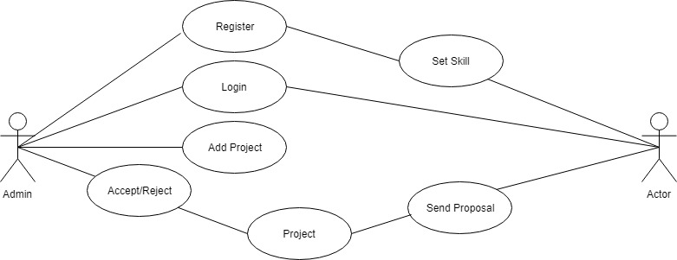

## 6.2 Context Level DFD: -

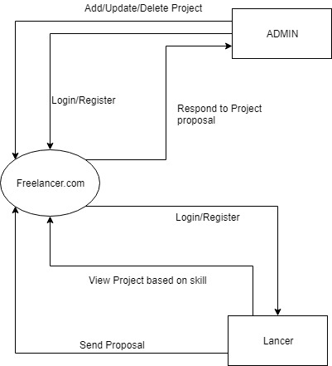

## 6.3 Flow Chart Diagram

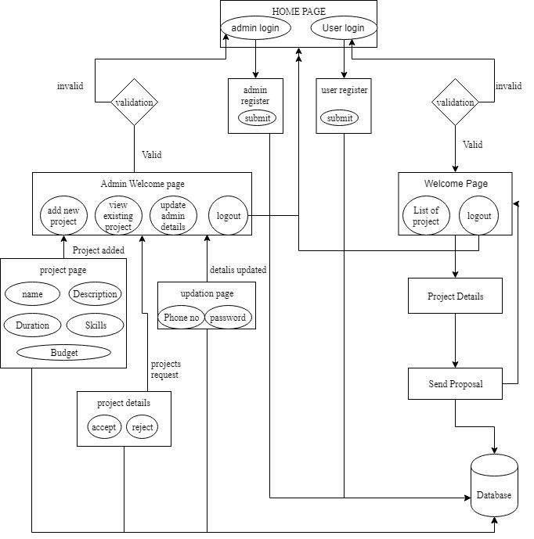

# 7. TESTING

Testing is the process of evaluating a system or its components with the intent to find that whether it satisfies the specified requirements or not. This activity results in the actual, expected and difference between their results i.e. testing is executing a system in order to identify any gaps, errors or missing requirements in contrary to the actual desire or requirements.

## 7.1 Testing Strategies

In order to make sure that system does not have any errors, the different levels of testing strategies that are applied at different phases of software development are



### 7.1.1 Unit Testing

The goal of unit testing is to isolate each part of the program and show that individual parts are correct in terms of requirements and functionality.

### 7.1.2 Integration Testing

The testing of combined parts of an application to determine if they function correctly together is Integration testing. This testing can be done by using two different methods

#### 7.1.2.1 Top Down Integration testing

In Top-Down integration testing, the highest-level modules are tested first and then progressively lower-level modules are tested.

#### 7.1.2.2 Bottom-up Integration testing

Testing can be performed starting from smallest and lowest level modules and proceeding one at a time. When bottom level modules are tested attention turns to those on the next level that use the lower level ones they are tested individually and then linked with the previously examined lower level modules. In a comprehensive software development environment, bottom-up testing is usually done first, followed by top-down testing.

### 7.1.3 System Testing

This is the next level in the testing and tests the system as a whole. Once all the components are integrated, the application as a whole is tested rigorously to see that it meets Quality Standards. 30

### 7.1.4 Acceptance Testing

The main purpose of this Testing is to find whether application meets the intended specifications and satisfies the client’s requirements. We will follow two different methods in this testing.

#### 7.1.4.1 Alpha Testing

This test is the first stage of testing and will be performed amongst the teams. Unit testing, integration testing and system testing when combined are known as alpha testing. During this phase, the following will be tested in the application:

* Broken Links.
* The Application will be tested on machines with the lowest specification to test loading times and any latency problems.

7.1.4.2 Beta Testing

In beta testing, a sample of the intended audience tests the application and send their feedback to the project team. Getting the feedback, the project team can fix the problems before releasing the software to the actual users. 31

## 7.2 Testing Methods

### 7.2.1 White Box Testing

White box testing is the detailed investigation of internal logic and structure of the Code. To perform white box testing on an application, the tester needs to possess knowledge of the internal working of the code. The tester needs to have a look inside the source code and find out which unit/chunk of the code is behaving inappropriately.

### 7.2.2 Black Box Testing

The technique of testing without having any knowledge of the interior workings of the application is Black Box testing. The tester is oblivious to the system architecture and does not have access to the source code. Typically, when performing a black box test, a tester will interact with the system’s user interface by providing inputs and examining outputs without knowing how and where the inputs are worked upon.

## 7.3 Validation

All the levels in the testing (unit integration, system) and methods (black box, white box) are implemented on our application successfully and the results obtained as expected.

## 7.4 Limitations

The execution time for support vector machine is more so that the user may not receive the result fast.

## 7.5 Test Results

The testing is done among the team members and by the end users. It satisfies the specified requirements and finally we obtained the results as expected.

TEST CASES 1 : Admin Login

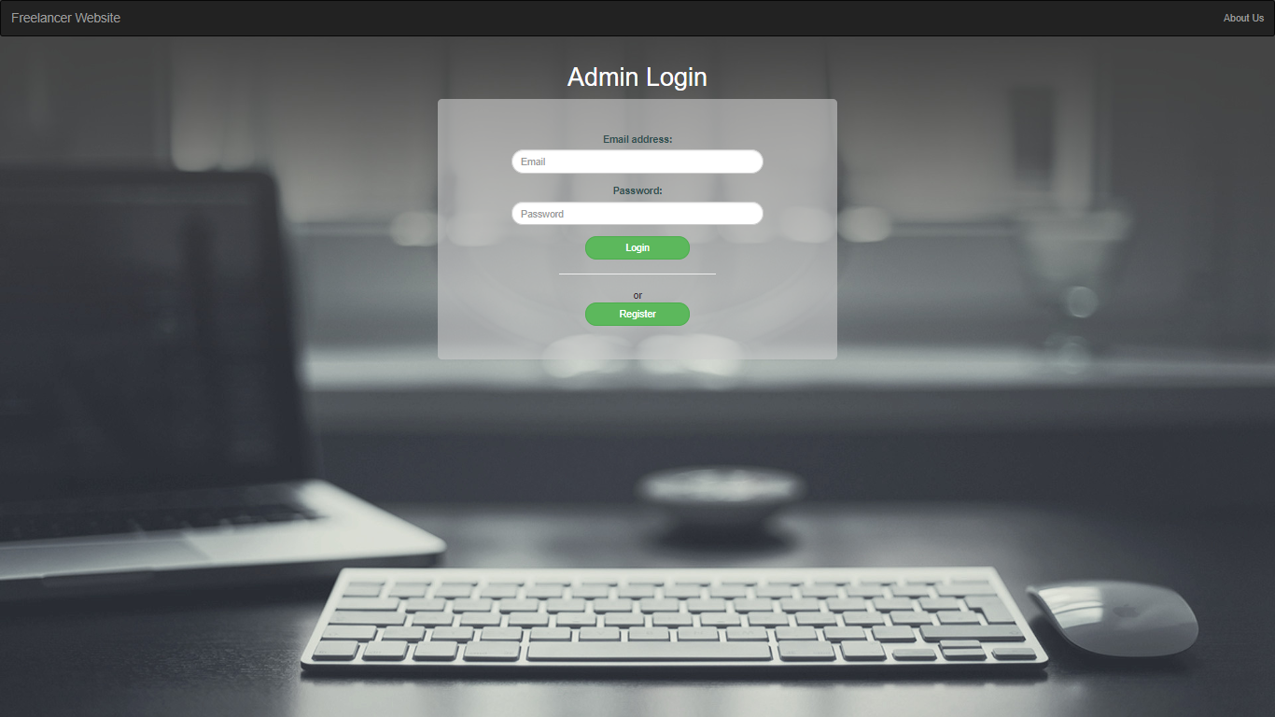

TEST CASES 2 : Lancer Login

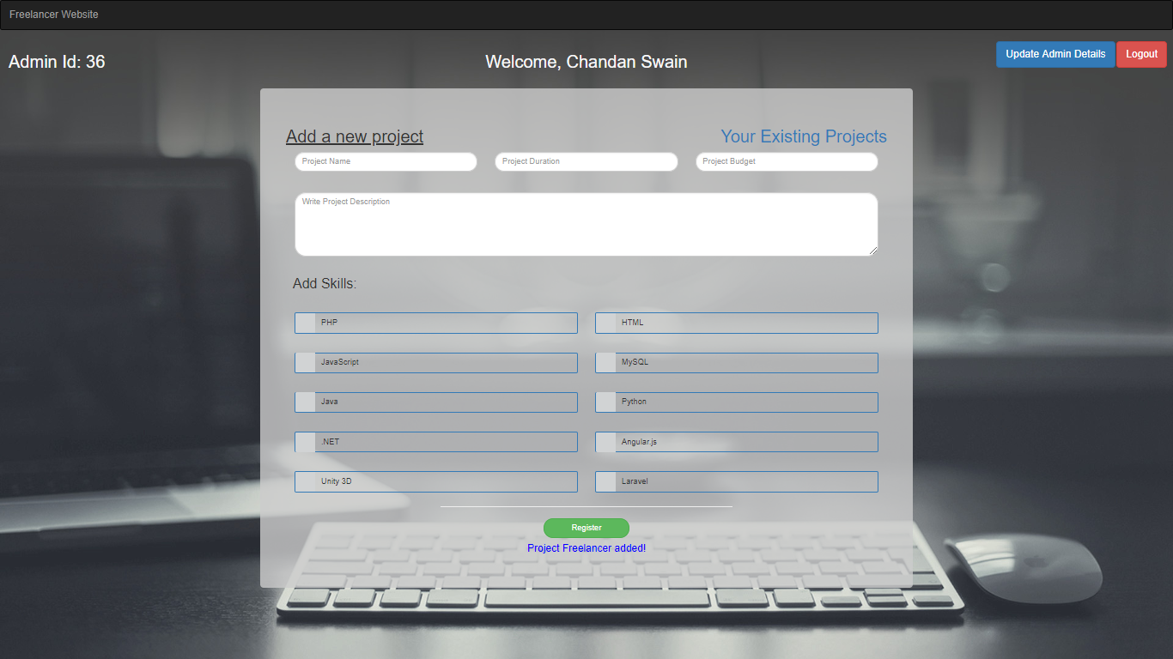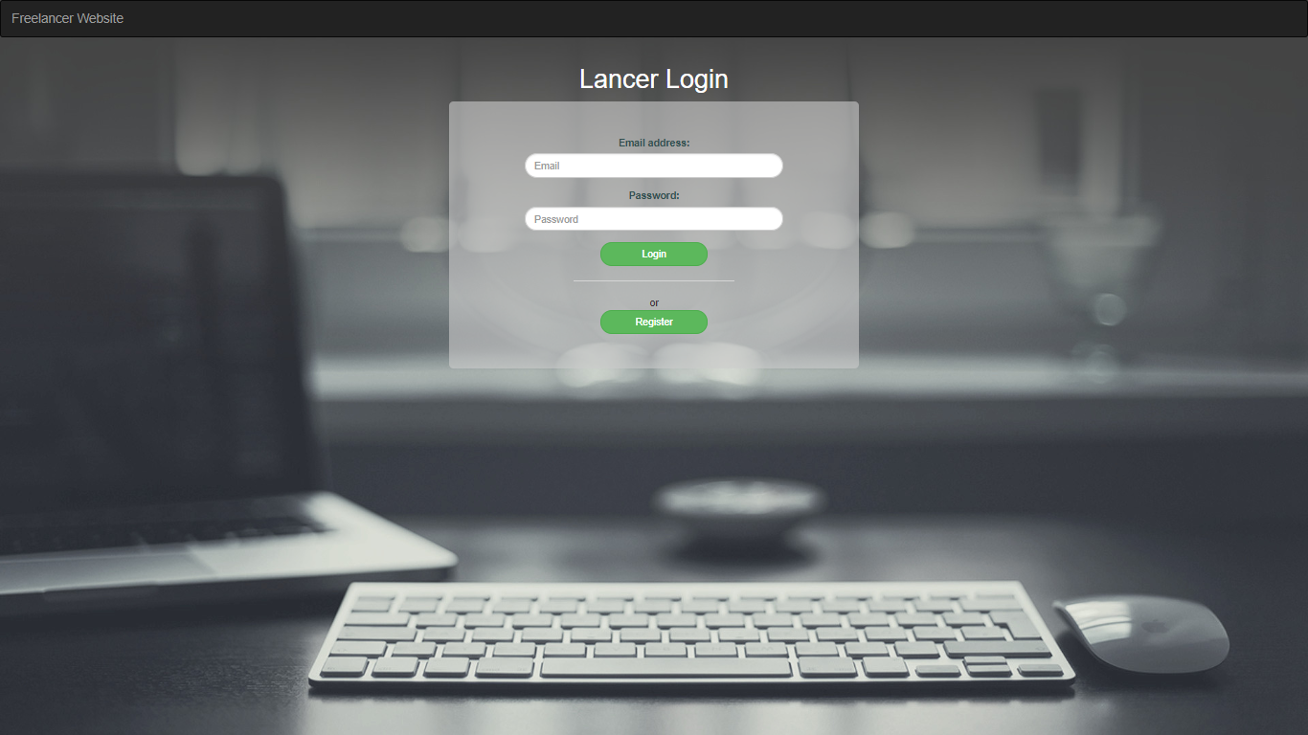

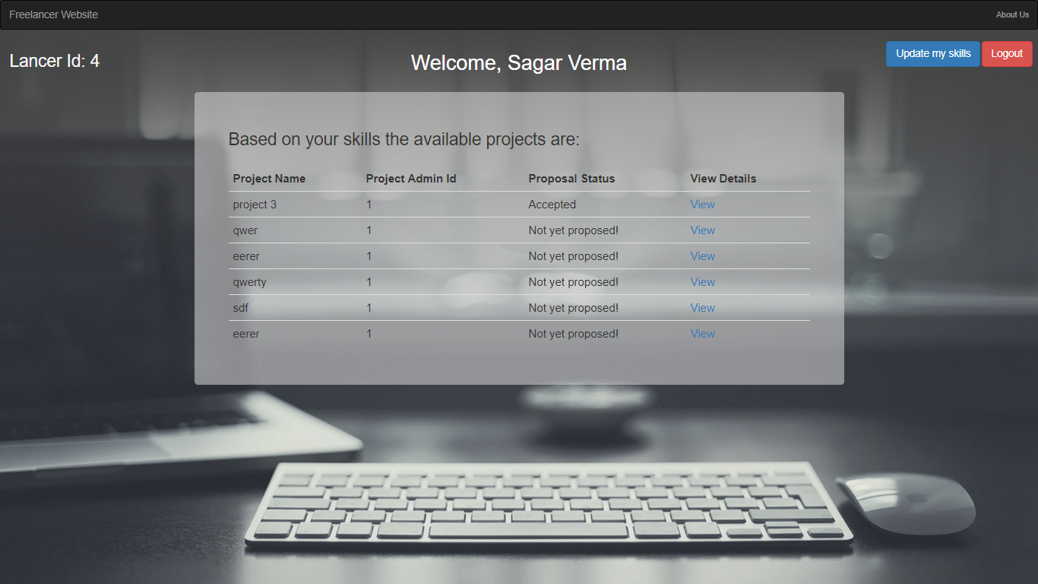

Test Case 3**:** Admin Registration

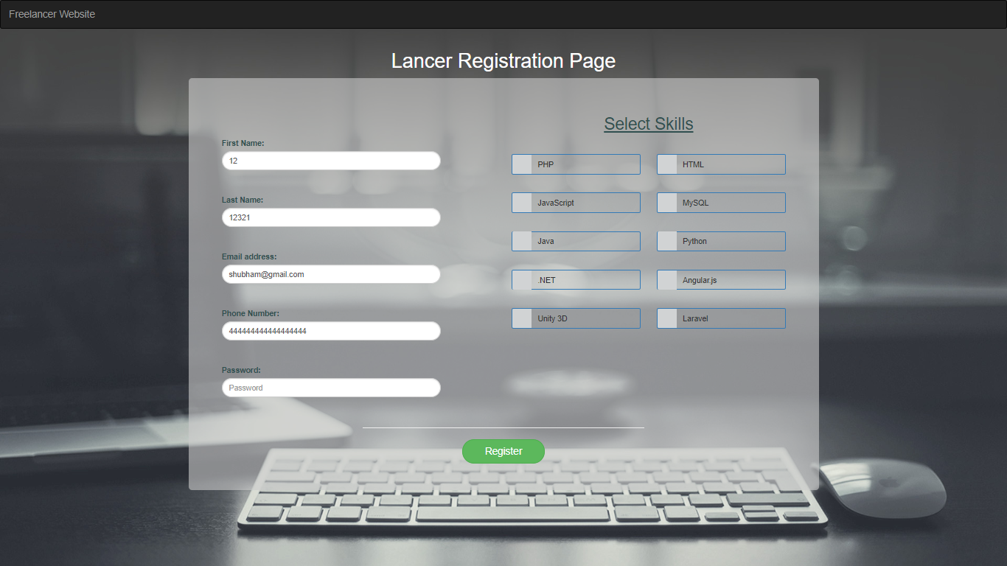

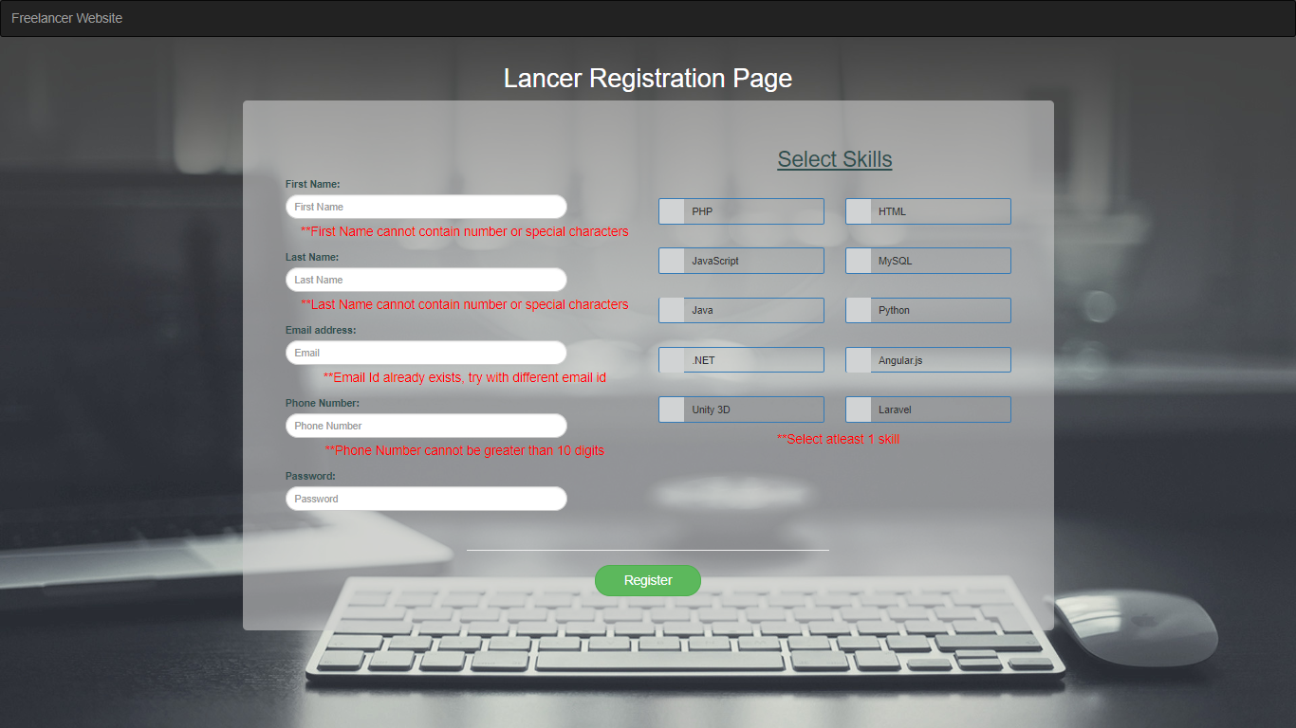

# 8. IMPLEMENTATION

Implementation is a realization of a technical specification or algorithm as a program, software component, or other computer system through computer programming and deployment. In our project we have implemented our modules through azure remote server

## 8.1 PROCESS

Software process as a framework for the tasks that are required to build high quality software. Or we can say that process defines the approach that is taken as software is engineered.

## 8.2 PROCESS MODEL USED BY US

### 8.2.1 Agile Methodology

Agile is a software development approach where a self-sufficient and cross-functional team works on making continuous deliveries through iterations and evolves throughout the process by gathering feedback from the end users.

AGILE methodology is a practice that promotes **continuous iteration** of development and testing throughout the software development lifecycle of the project.

The agile software development emphasizes on four core values.

1.Individual and team interactions over processes and tools

2.Working software over comprehensive documentation

3.Customer collaboration over contract negotiation

4.Responding to change over following a plan.

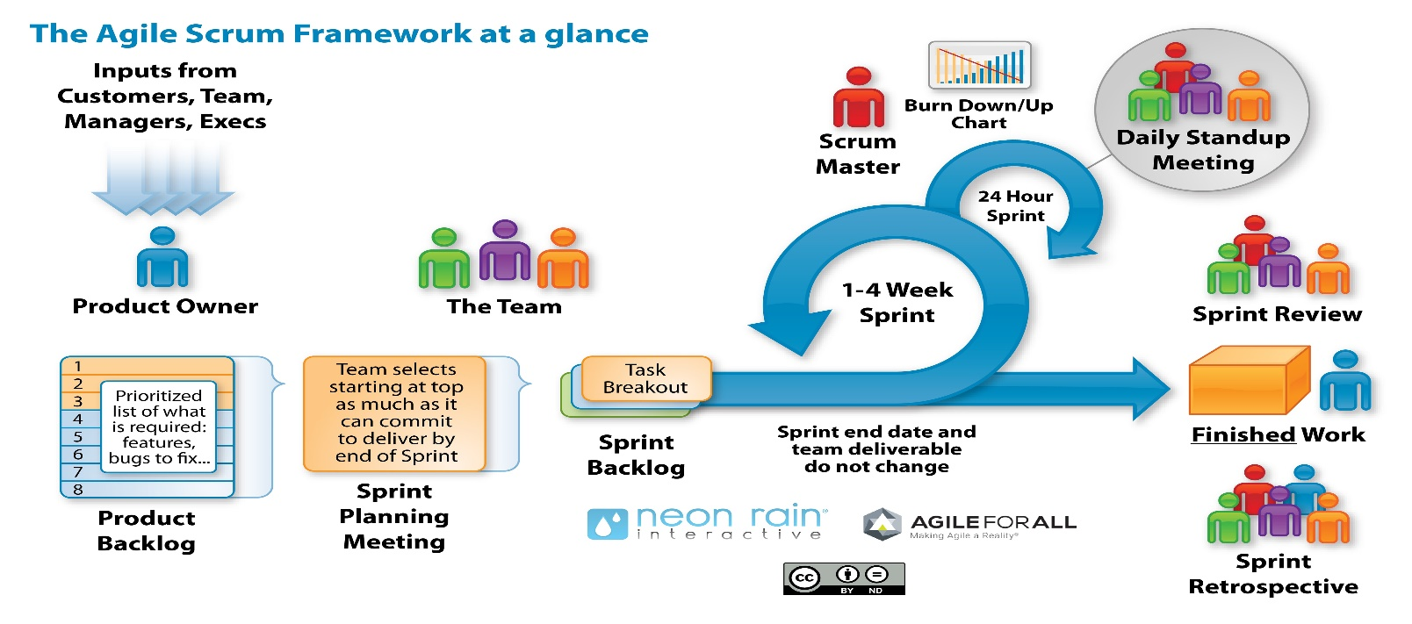

In our project we are using Scrum Agile Methodology

### 8.2.1.1 Scrum

SCRUM is an agile development method which concentrates specifically on how to manage tasks within a team-based development environment. Basically, Scrum is derived from activity that occurs during a rugby match. Scrum believes in empowering the development team and advocates working in small teams (say- 7 to 9 members). It consists of four roles, and their responsibilities are explained as follows:

* Product owner
  + The Product owner provides specification and requirement of the project and also provide the time stamp in which the project must be completed. The review of project is taken care by product owner end when the project is ready to serve and brought out for demo.
* Proxy product owner
  + The proxy product owner understands the project requirement from the product owner and assign them to a particular development team and scrum master associated with it. The frequent reviews of project are taken care by the proxy product owner. In our project proxy product owner are cognizant Business Analysts (BA).
* Scrum Master
  + Master is responsible for setting up the team, sprint meeting and removes obstacles to progress and take the status of the task assigned to each individual of development team on daily basis.
* Development Team
  + 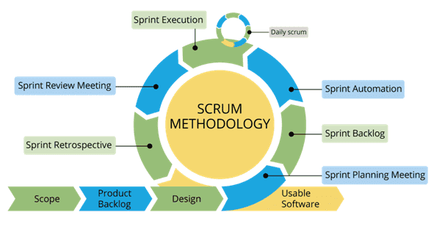Team manages its own work and organizes the work to complete the sprint or cycle. Development team consists of UI/UX Developer, service layer developer, database management team, tester, architecture.

## 8.3 CONVERSION PLAN

To make this project live, i.e., to build the project followed:

1. Firstly, senior architect and business analyst analyzes the project requirement in terms of hardware and software needed in the project.
2. Senior architecture asks infrastructure team to provide resources for client specifications.
3. Infrastructure team provide the software and hardware requirements for the specification asked by senior architecture. For our project the hardware and software requirements provided by infrastructure team is as follow:
4. Installation of Node and Visual Studio Code.
5. Installation of angular cli, Express and PostgreSQL.
6. Once the angular cli set up successfully then setup PostgreSQL.
7. Then access the software via remote server.

5.The application is now live and open for target organization.

# 9 PROJECT LEGACY

## 9.1 Current State of the project

All the modules of project are in complete working state. Lancer can register themselves and give all the necessary details. Lancer can also view projects details, budget and duration. Lancer is showcased project based on skills and he can send proposal for project.

Admin can register himself and upload projects on the basis of his requirement. Admin can accept the proposal or reject the proposal sent to him by the lacer.

## 9.2 Technical and Managerial lessons learnt

### 9.2.1 Technical lessons learnt

1. Spring MVC for making the application
2. Hibernate for creating the database and managing it.
3. Bootstrap, CSS, Java Script for making the UI.

### 9.2.2 Managerial lessons learnt

i. Working in a team

ii. Project Planning

iii. The whole project is discussed with mentor and team members

iv. Time management

# 10.USER INTERFACE SCREENSHOTS

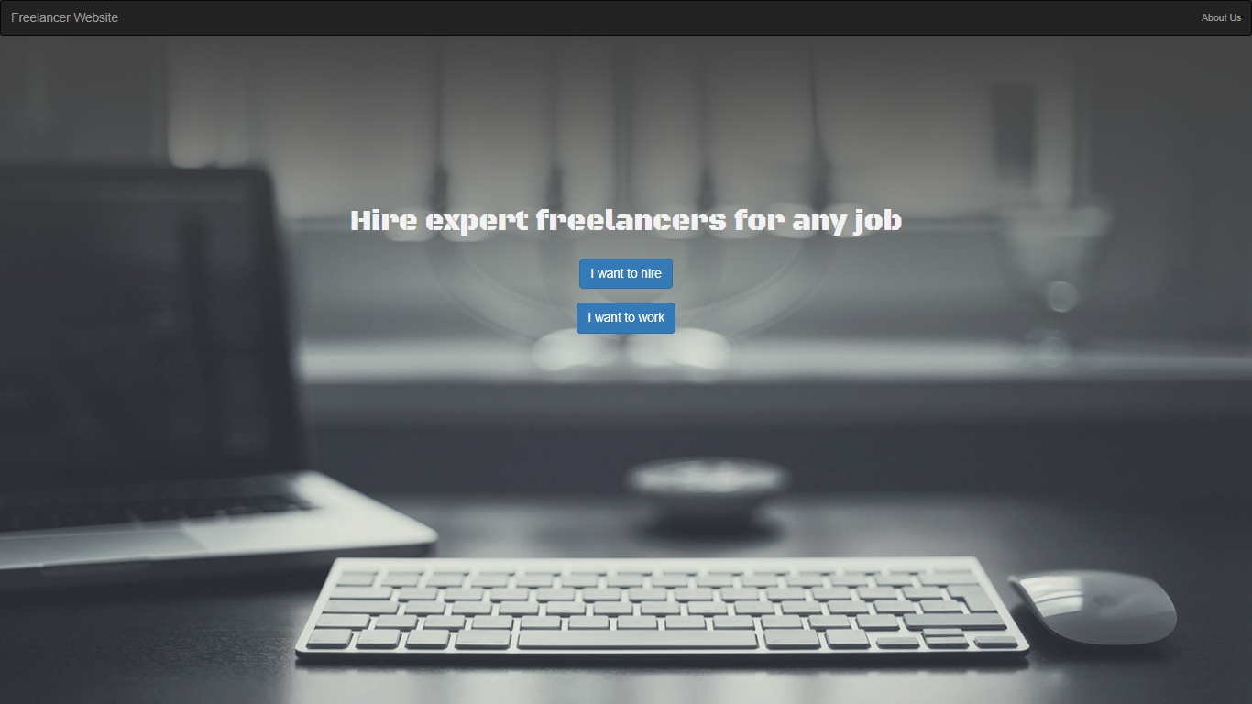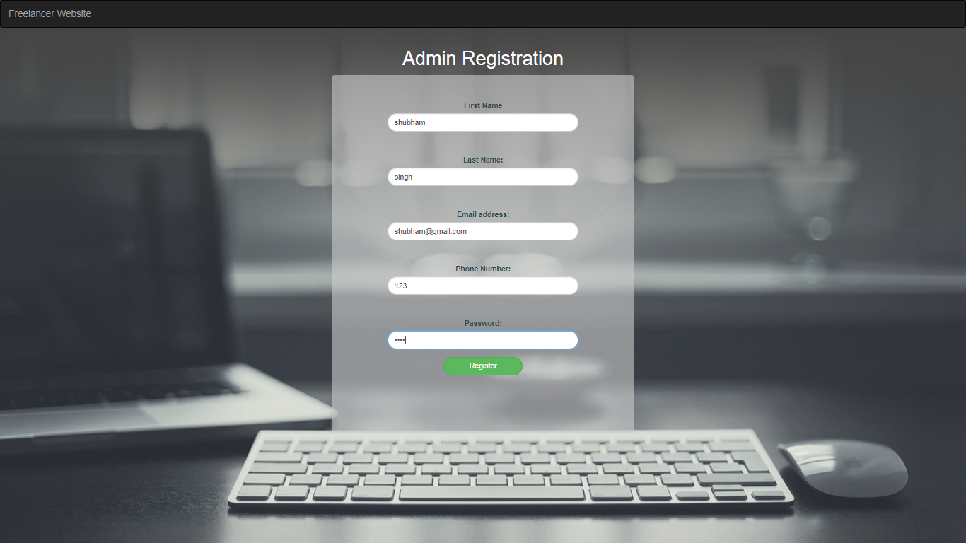

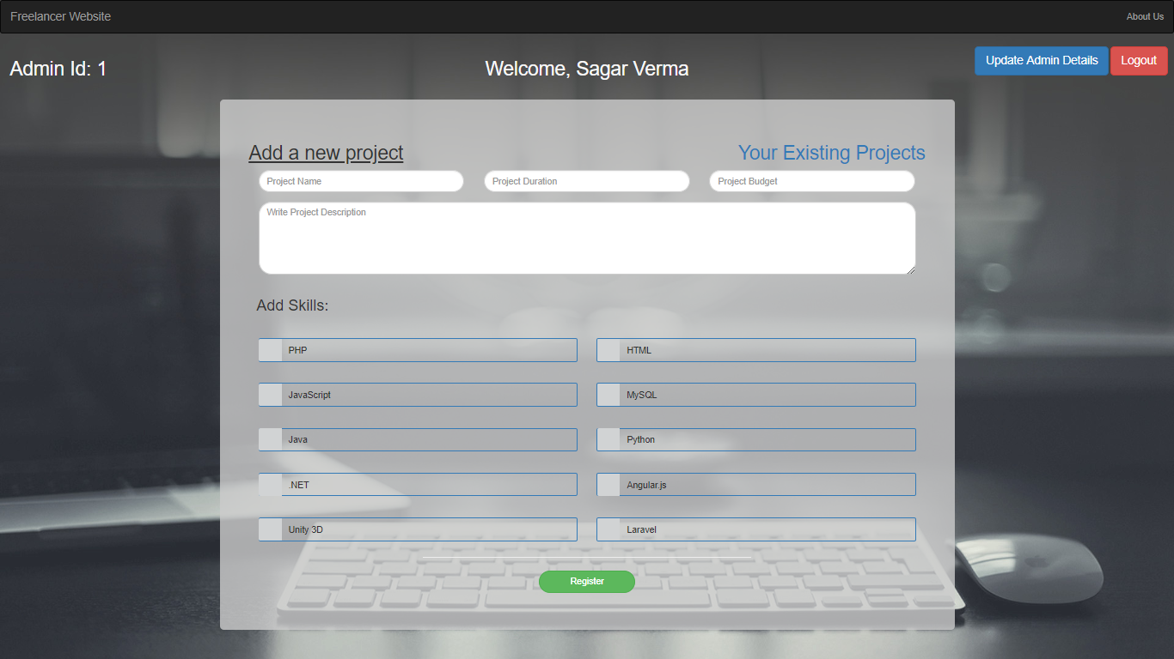

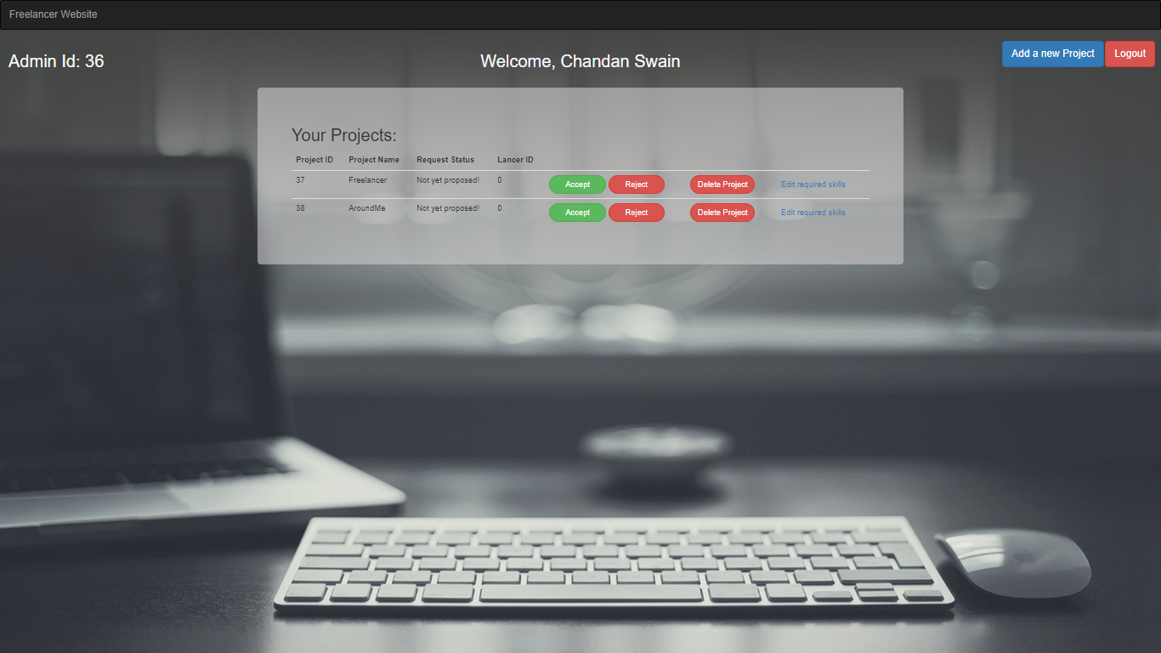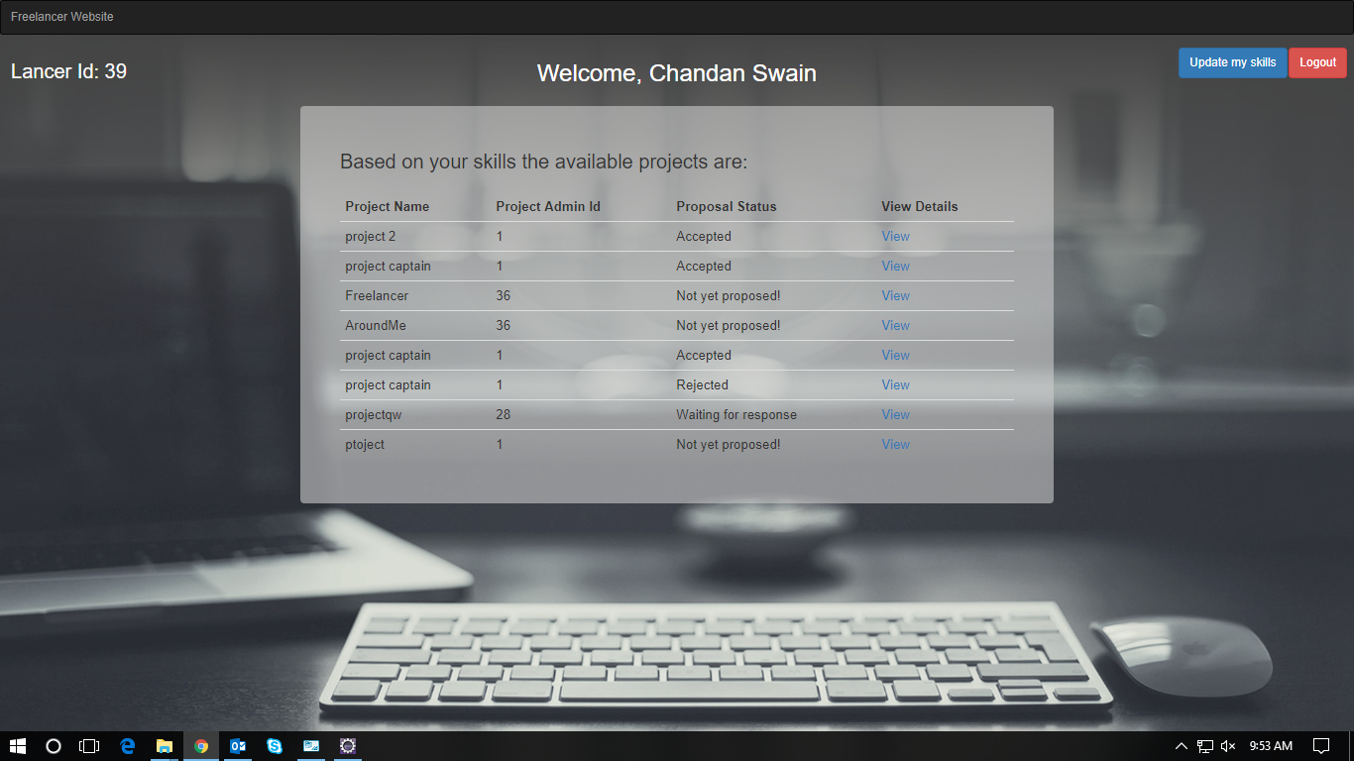

# 11.Bibliography

[1] https://www.tutorialspoint.com

[2] https://getbootstrap.com/docs/4.1/getting-started/introduction/

[3] https://www.javatpoint.com/

[4] https://www.w3schools.com/bootstrap4/